EXPLORATORY DATA ANALYSIS OF THE DANISH HOUSING MARKET: A DATA-DRIVEN APPROACH TO PROPERTY PRICE DETERMINANTS

A PROJECT SUBMITTED IN PARTIAL FULFILLMENT OF THE REQUIREMENTS FOR THE AWARD OF A PROFESSIONAL CERTIFICATE IN MACHINE LEARNING, DATA SCIENCE, DATA ANALYSIS USING PYTHON PROGRAMMING AND MY SQL

BY

AKINLADE AYOMIKUN DORCAS

VALUEMAX CODERS’ HUB
30, OYO ROAD, OPPOSITE UNIVERSITY OF IBADAN POST OFFICE, IBADAN, NIGERIA
TUTOR: MR SAMUEL A. MISOJEUN

8TH JULY, 2026

DEDICATION
I humbly dedicate this project to God Almighty for His guidance, strength, and unwavering support throughout this academic journey.
To God be the Glory.

ACKNOWLEDGEMENT
First and foremost, I thank God Almighty for His guidance, wisdom, and strength throughout this project.
My heartfelt thanks go to my family for their encouragement and support throughout this journey. I also wish to express my sincere gratitude to Mr. Samuel A. Misojeun, my instructor at ValueMax Coders Hub for his invaluable guidance and support.

ABSTRACT
The housing market plays a critical role in the economic development of every nation, serving as both an investment opportunity and a basic human necessity. This study explores the Danish housing market using Exploratory Data Analysis (EDA) techniques to identify the major factors influencing residential property prices. A comprehensive dataset containing property characteristics, transaction prices, geographical information, mortgage rates, and construction years was analyzed using Python libraries such as Pandas, NumPy, Matplotlib, and Seaborn.
The study examined the distribution of housing prices across different regions and property types, investigated temporal trends in prices and sales volume, analyzed negotiation patterns between asking and purchase prices, and evaluated the influence of property age, size, and construction decade on market value. Correlation analysis was also conducted to determine relationships between numerical variables.
The findings reveal that price per square meter is the strongest predictor of housing prices, while larger homes generally command higher market values. Housing prices have steadily increased over time despite fluctuations in sales volume. Zealand consistently records the highest property prices, whereas Bornholm remains the least expensive region. Buyers generally negotiate below asking prices regardless of property type. The results provide valuable insights for homebuyers, investors, policymakers, and real estate professionals in understanding market dynamics and making informed decisions.

Keywords: Exploratory Data Analysis, Housing Market, Denmark, Real Estate, Python, Data Visualization, Property Prices.

TABLE OF CONTENTS
Contents Page
Dedication
Acknowledgements
Abstract
Table of Contents
Chapter One: Introduction
Chapter Two: Literature Review
Chapter Three: Methodology
Chapter Four: Results and Discussion
Chapter Five: Conclusion and Recommendations
References

CHAPTER ONE
INTRODUCTION
1.1 Background of the Study
Real estate remains one of the largest sectors contributing to national economic growth. Housing prices are affected by numerous interconnected variables including location, property size, age, market demand, interest rates, and economic conditions. Understanding these relationships has become increasingly important due to rapid urbanization, inflation, and changing mortgage policies.
Denmark possesses one of Europe's most transparent housing markets, characterized by publicly available transaction data and stable economic indicators. This makes it an ideal case study for applying data analytics techniques.
Exploratory Data Analysis (EDA) provides an effective approach for uncovering hidden patterns, identifying anomalies, and generating insights from large datasets before predictive modeling. Through visualization and descriptive statistics, EDA enables analysts to understand complex market behavior.
This study employs EDA techniques to investigate the Danish housing market and identify the key factors influencing residential property prices.

1.2 Problem Statement
Although large volumes of housing data are available, extracting meaningful insights remains challenging due to the complexity of multiple interacting variables. Buyers often struggle to determine fair prices, investors face uncertainty regarding profitable investments, and policymakers require accurate market intelligence.
There is therefore a need for a comprehensive exploratory analysis capable of revealing hidden relationships among housing characteristics, regional differences, property age, construction periods, and pricing trends.

1.3 Aim of the Study
The aim of this study is to perform an exploratory data analysis of the Danish housing market to identify factors influencing residential property prices.

1.4 Objectives
The objectives are to:
- Explore the distribution of properties across Danish regions.
- Analyze housing prices across different property types.
- Examine trends in housing prices over time.
- Investigate sales volume over time.
- Compare housing prices among regions.
- Evaluate negotiation differences between asking and purchase prices.
- Examine the effect of property age on average housing prices.
- Analyze construction decades and their influence on pricing.
- Determine relationships among housing variables using correlation analysis.

1.5 Research Questions
- Which Danish region has the highest housing prices?
- Which property type dominates the market?
- How have housing prices changed over time?
- Does property age affect purchase price?
- What variables have the strongest influence on housing prices?
- Do buyers generally pay above or below asking prices?

1.6 Significance of the Study
The findings will benefit:
- Home buyers seeking investment guidance.
- Real estate agencies.
- Property investors.
- Financial institutions.
- Government housing authorities.
- Researchers in housing economics.

CHAPTER TWO
LITERATURE REVIEW
2.1 Introduction
Housing markets have attracted extensive academic interest because of their importance to economic growth, wealth creation, and social welfare. Advances in data analytics have significantly improved the understanding of real estate pricing through statistical and machine learning methods.

2.2 Concept of Exploratory Data Analysis
Exploratory Data Analysis (EDA), introduced by John Tukey (1977), refers to the process of examining datasets through summary statistics and visualizations before applying predictive models. EDA helps identify trends, missing values, correlations, distributions, and outliers.
According to Tukey, EDA allows analysts to "listen to the data" before drawing conclusions.

2.3 Housing Market Analysis
Housing markets are influenced by both internal and external factors including:
- Location
- Property size
- Number of rooms
- Construction quality
- Accessibility
- Interest rates
- Inflation
- Economic growth
Numerous studies show that location consistently remains the strongest determinant of housing prices.

2.4 Property Characteristics and Housing Prices
Research by Rosen (1974) introduced the Hedonic Pricing Model, explaining that house prices are determined by bundles of characteristics rather than individual features.
Common determinants include:
- Square meters
- Bedrooms
- Bathrooms
- Construction year
- Neighborhood quality
- Accessibility
The correlation analysis strongly supports this theory by showing that price per square meter exhibits the highest positive relationship with purchase price (0.82).

2.5 Regional Differences in Housing Markets
Several studies indicate that urban regions generally command higher property prices due to stronger economic activity and greater demand.
The analysis confirms this finding:
- Zealand has the highest housing prices.
- Bornholm has the lowest prices.
- Jutland contains the largest share of housing transactions.

2.6 Property Age and Housing Prices
Older buildings may depreciate because of maintenance costs, although historic properties may appreciate due to architectural value.
The analysis shows:
- Newer houses (0–10 years) possess the highest average prices.
- Prices gradually decline with increasing property age.
- Slight recovery is observed among very old properties, possibly due to historical or luxury characteristics.

2.7 Interest Rates and Housing Prices
Mortgage interest rates significantly influence housing demand.
Higher interest rates reduce affordability and often suppress housing prices.
The correlation analysis indicates a weak negative relationship between interest rates and purchase prices, consistent with economic theory.

2.8 Research Gap
Most previous studies emphasize predictive modeling using machine learning. However, relatively fewer studies focus exclusively on comprehensive exploratory analysis integrating regional distributions, negotiation outcomes, temporal trends, construction decades, and property characteristics within the Danish housing market.
This study fills this gap by providing a holistic exploratory analysis.

CHAPTER THREE
METHODOLOGY
3.1 Research Design
An exploratory quantitative research design was adopted.
3.2 Data Source
The study used a Danish housing transaction dataset containing information on:
- Purchase price
- Asking price
- Region
- Property type
- Construction year
- Property size
- Number of rooms
- Interest rates
- Mortgage bond yields
- Transaction dates
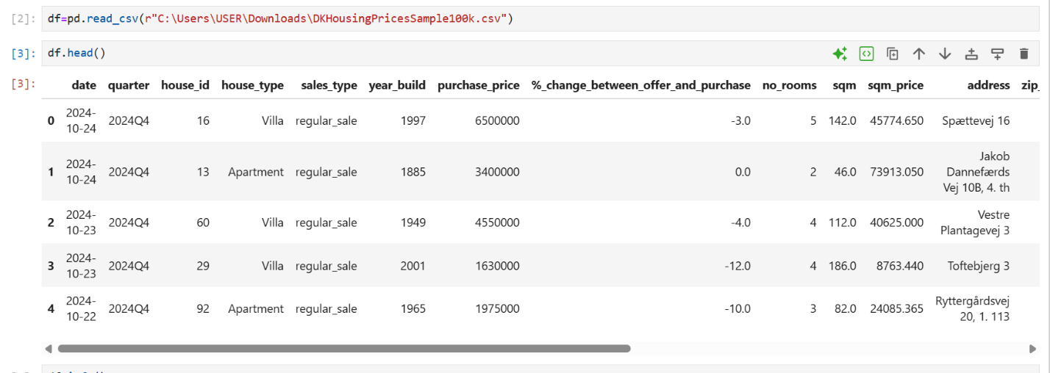
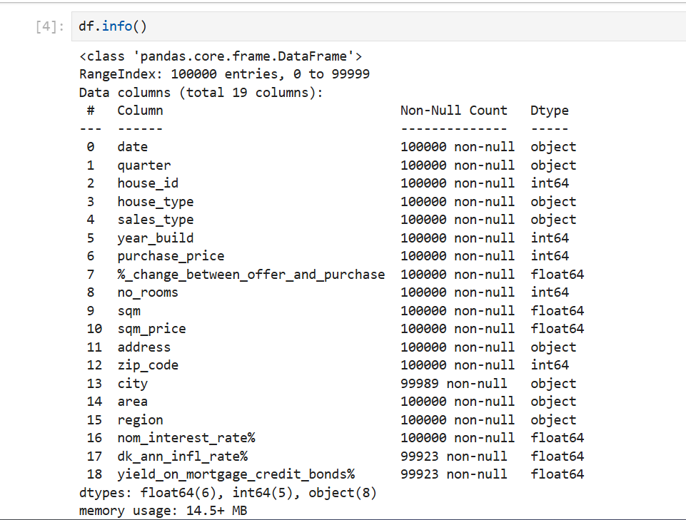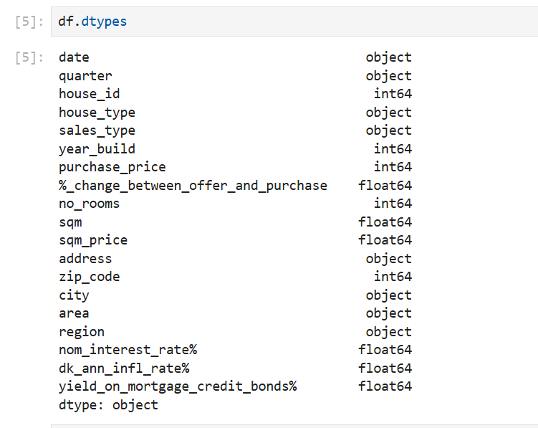
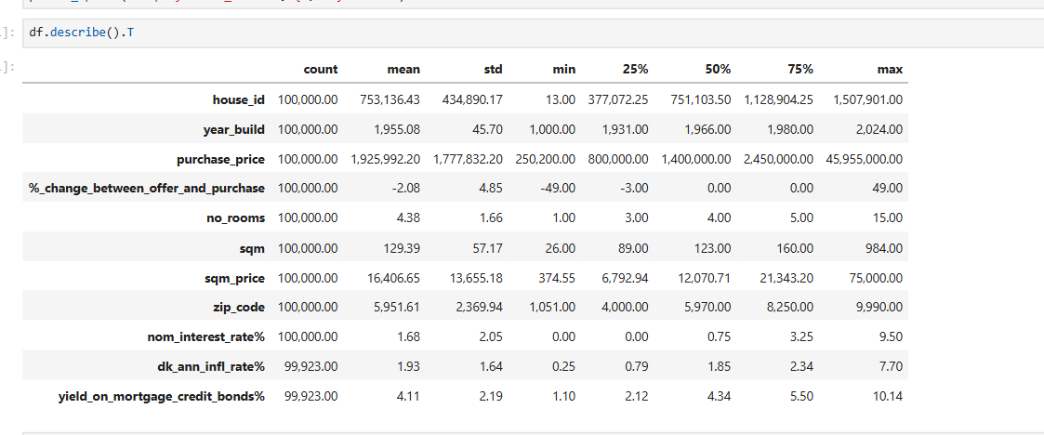
3.3 Software
- Python
- Jupyter Notebook

3.4 Libraries Used
- Pandas
- NumPy
- Matplotlib
- Seaborn

3.4 Data Cleaning
The dataset underwent:
- Missing value treatment, Data type conversion and Outlier Handling by Capping
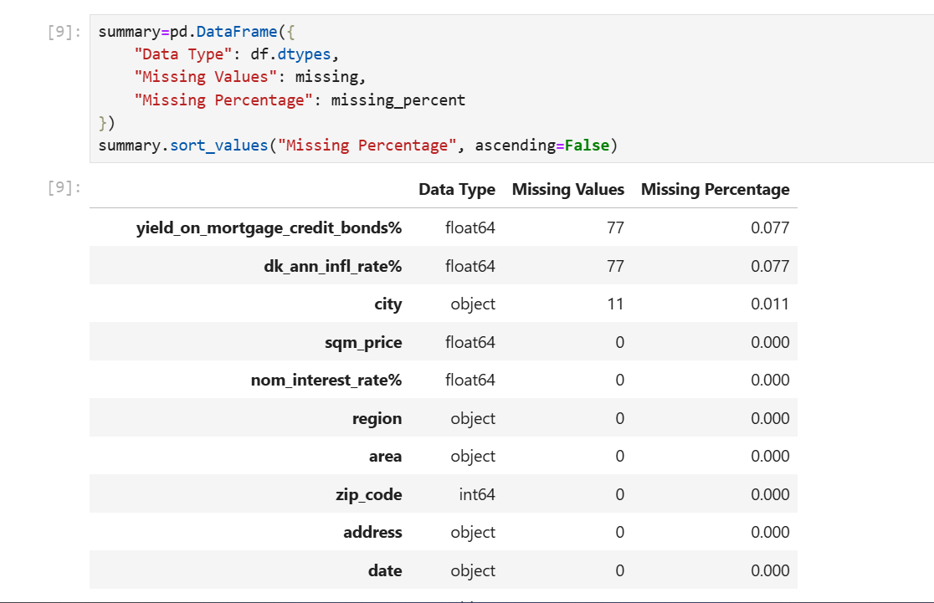
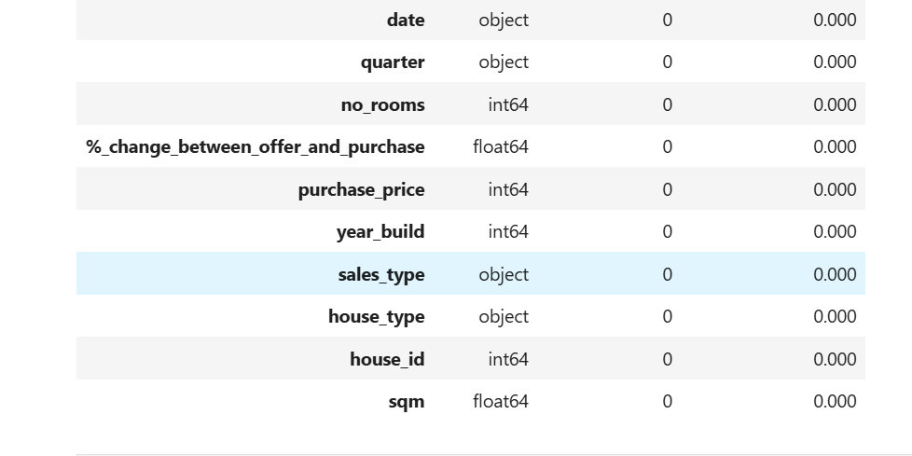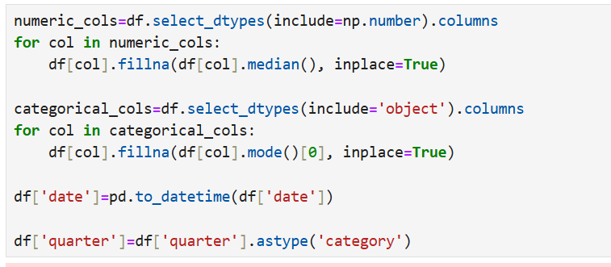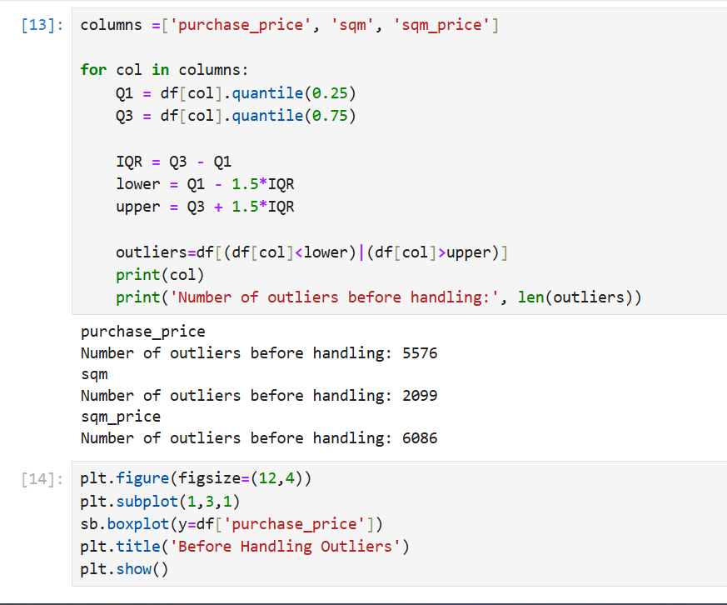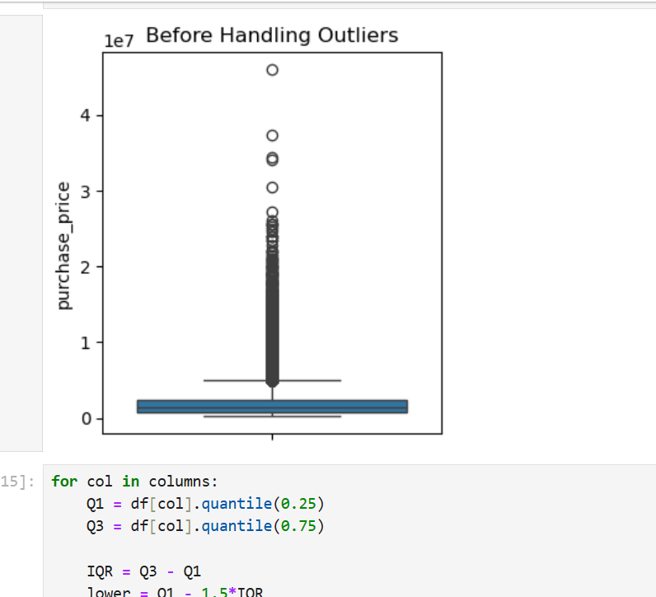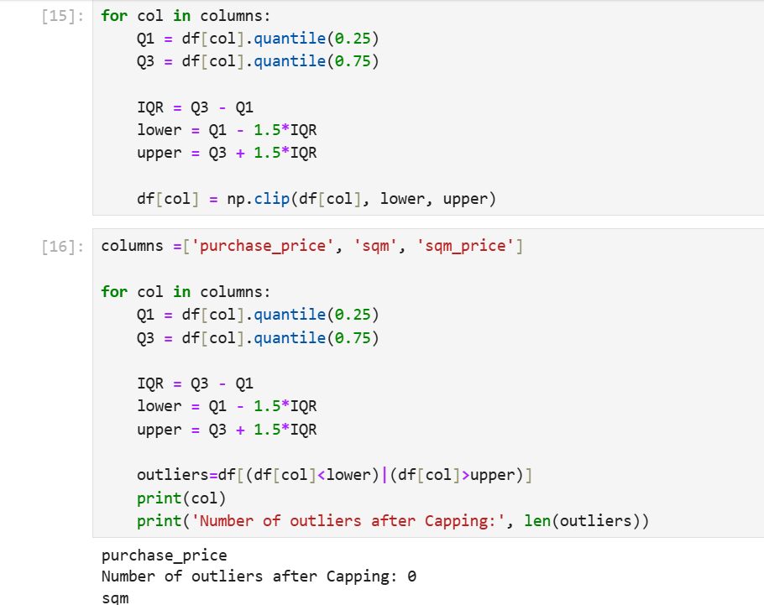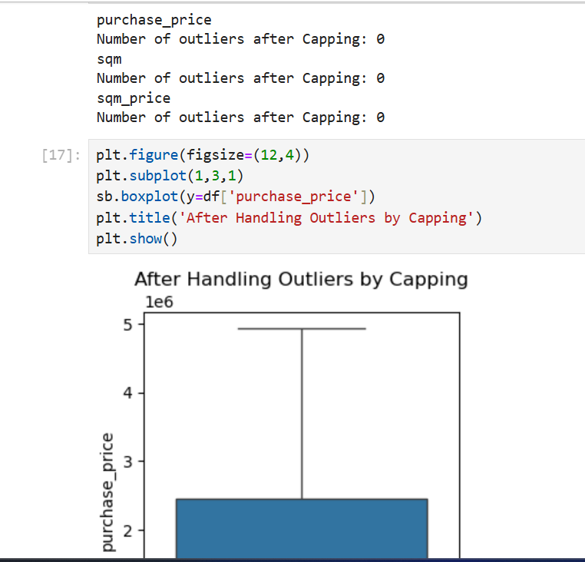
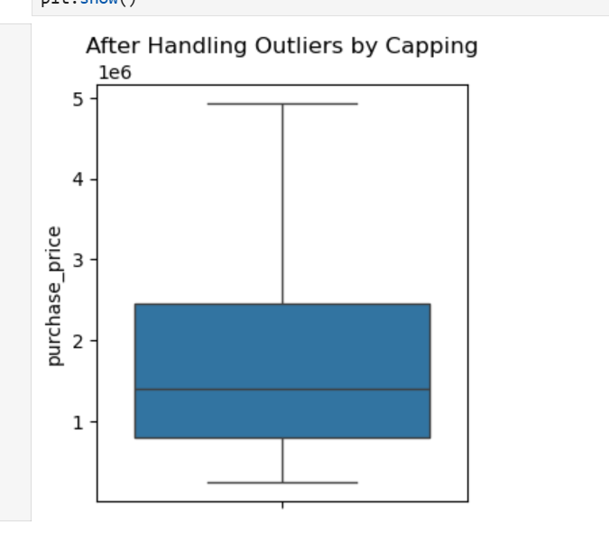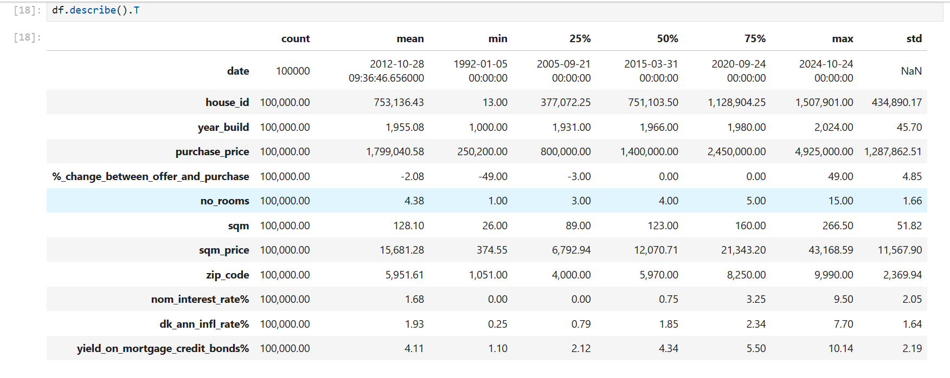

New variables created included:
- Property age and age groups
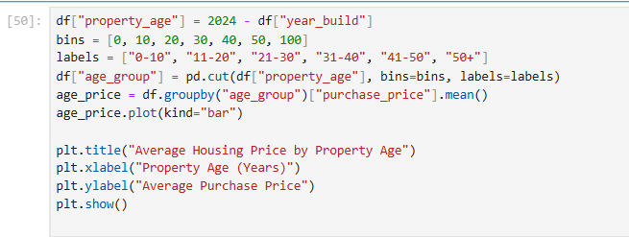
- Construction decade
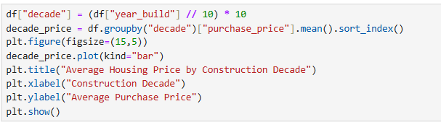

3.5 Analytical Techniques
The following analyses were conducted:
- Descriptive statistics
- Correlation analysis
- Histograms
- Pie charts
- Bar charts
- Box plots
- Line charts
- Heatmaps

CHAPTER FOUR
RESULTS AND DISCUSSION
  - Distribution Across Regions
Nearly half of all properties are located in Jutland (49.9%), followed by Zealand (39.7%). Bornholm accounts for the smallest proportion (1.1%), indicating a much smaller housing market.
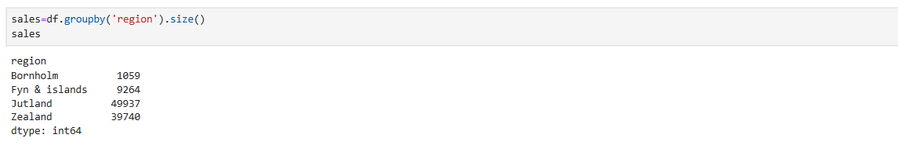
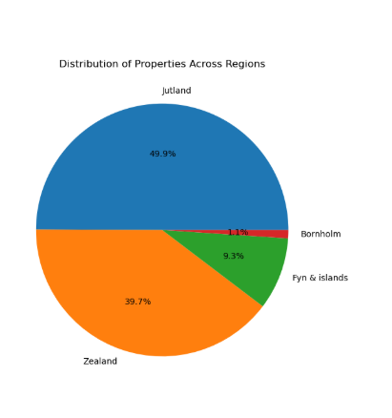
  - Property Types
Villas dominate the Danish housing market (54.2%), followed by apartments (19.4%). Farms account for the fewest listings.
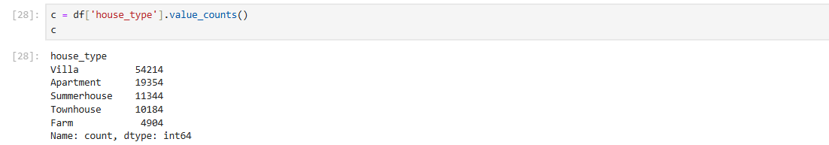
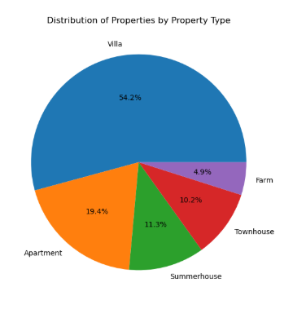

  - Purchase Price Distribution
Housing prices exhibit a right-skewed distribution, with most properties clustered in lower-to-middle price ranges and a smaller number of premium properties.
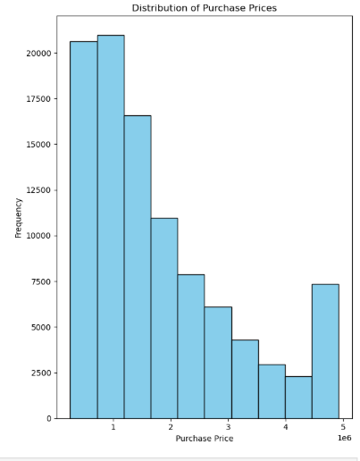
  - Housing Price Trend
Average housing prices have steadily increased over the years, reflecting long-term appreciation despite short-term fluctuations.
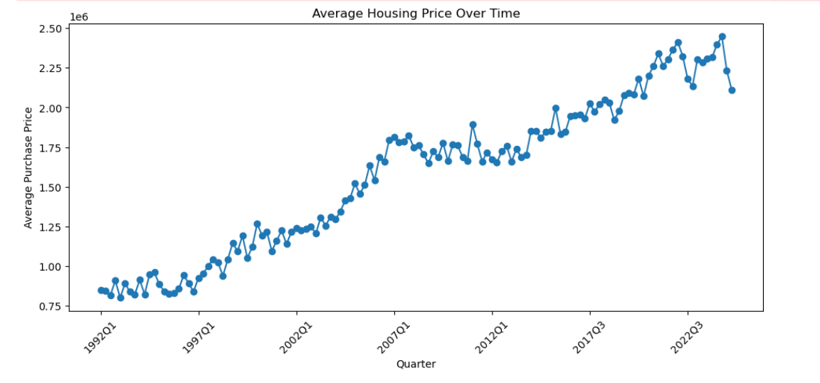
  - Sales Volume Trend
Sales volume has generally increased over time but shows periodic fluctuations due to changing market conditions. A sharp decline in the latest period is likely due to incomplete quarterly data.

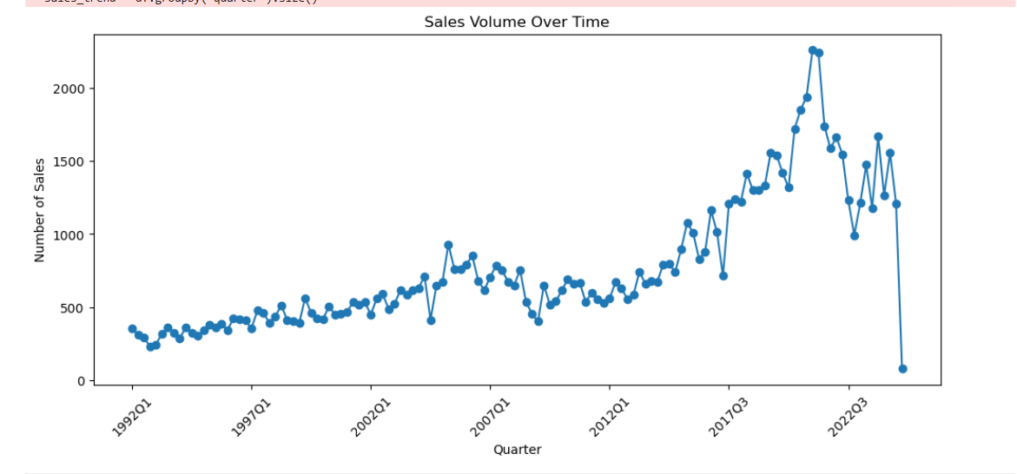

  - Regional Price Comparison
The box plot shows that Zealand consistently records the highest median housing prices and the widest price variation, while Bornholm records the lowest prices.
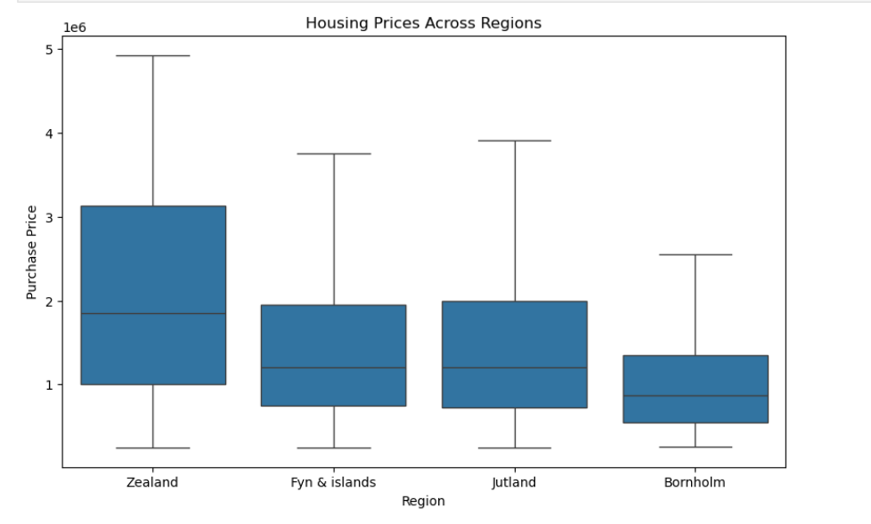

  - Correlation Analysis
The heatmap reveals:
- Price per square meter has the strongest positive correlation with purchase price (0.82).
- Property size shows a moderate positive relationship.
- Mortgage bond yields exhibit negative relationships.
- Interest rates display weak negative correlations.
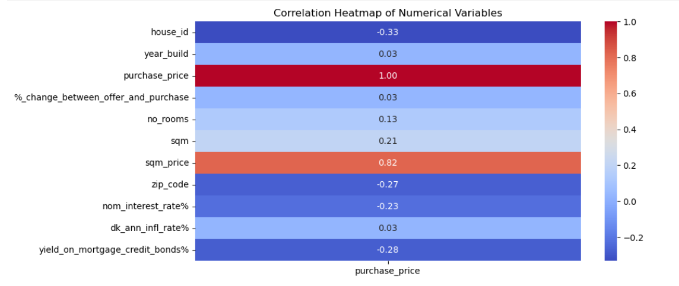

  - Negotiation Analysis
All property types were purchased below asking prices, indicating successful buyer negotiations across all Danish regions.
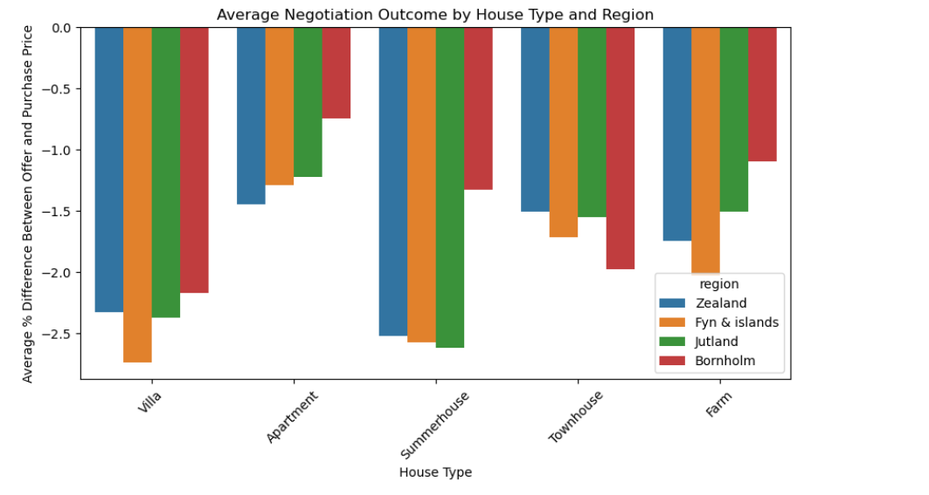

  - Property Age Analysis
Properties aged 0–10 years have the highest average purchase prices. Prices generally decrease as property age increases, although properties over 50 years show slight recovery.
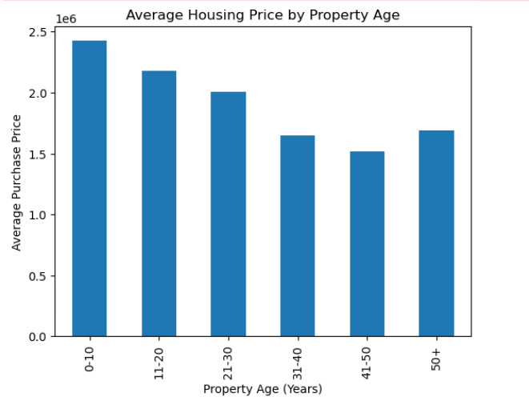
  - Construction Decades
Average housing prices vary considerably across construction decades, suggesting that architectural standards, modernization, and market demand influence valuation.
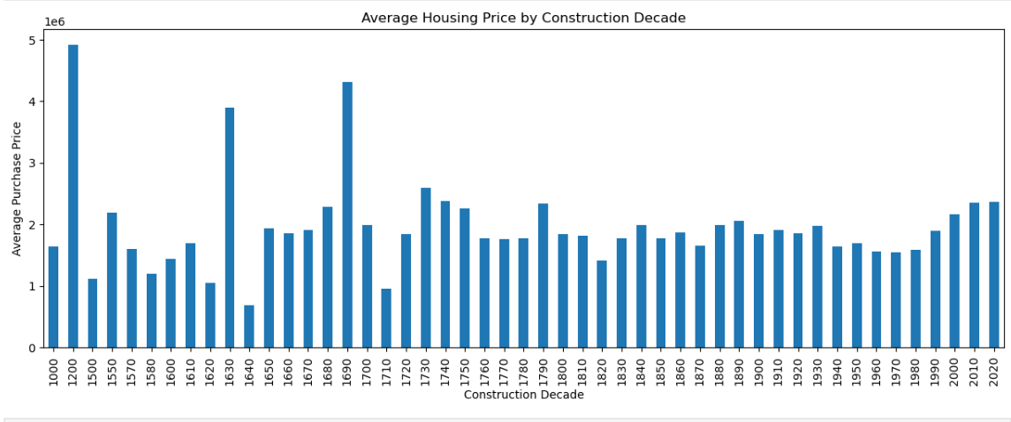
CHAPTER FIVE
CONCLUSION AND RECOMMENDATIONS
5.1 Conclusion
This study successfully applied Exploratory Data Analysis techniques to investigate the Danish housing market. The findings demonstrate that property size, price per square meter, location, and construction characteristics significantly influence residential property prices.
The analysis also reveals steady long-term price appreciation, regional disparities in market values, and consistent buyer negotiation below asking prices.
Overall, the project illustrates how data analytics can support evidence-based decision-making in real estate.

5.2 Recommendations
- Buyers should prioritize location and price per square meter when evaluating properties.
- Investors should focus on Zealand for premium investments and Jutland for higher transaction volumes.
- Policymakers should monitor regional disparities to promote balanced housing development.
- Real estate agencies should leverage data analytics for more accurate pricing strategies.
- Future studies should integrate predictive machine learning models to forecast housing prices.

LIMITATIONS
- The analysis is limited to one dataset.
- External macroeconomic variables such as inflation and unemployment were not fully explored.
- Some recent sales data may be incomplete.
- Only exploratory analysis was conducted; predictive modeling was outside the scope.

FUTURE WORK
Future research could:
- Develop predictive models using Random Forest, XGBoost, or Neural Networks.
- Perform geospatial analysis using GIS data.
- Analyze the impact of environmental and energy-efficiency factors.
- Compare Danish housing trends with other Nordic countries.

REFERENCES
Rosen, S. (1974). Hedonic prices and implicit markets: Product differentiation in pure competition. Journal of Political Economy, 82(1), 34–55.
Tukey, J. W. (1977). Exploratory Data Analysis. Addison-Wesley.
James, G., Witten, D., Hastie, T., & Tibshirani, R. (2021). An Introduction to Statistical Learning (2nd ed.). Springer.
Han, J., Kamber, M., & Pei, J. (2012). Data Mining: Concepts and Techniques (3rd ed.). Morgan Kaufmann.
Hair, J. F., Black, W. C., Babin, B. J., & Anderson, R. E. (2019). Multivariate Data Analysis (8th ed.). Cengage Learning.

